PHP and MySQL

Session 8 Practical:

Db Connectivity and Testing

Exercise 1
The first exercise you create this week will generate a random set of lottery numbers. Create the script below and name it wk9ex1.php.

<?php
$lottodate = date("dmY");
echo "The lottery numbers for $lottodate are ";
for($n=1;$n<7;$n++){
$number[$n] = rand(1,49);
echo "<br/> $number[$n]";
}
?>

Run the script several times to check that the numbers generated are in fact random.

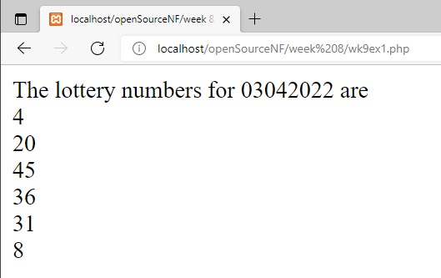
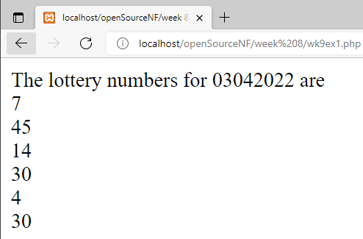

Exercise 2
We will now create a table in which to store the numbers. Within your database, create the table with the following structure.

Remember that before you create the table you must first be logged into MySQL (phpMyAdmin) and have selected the database.

create table lotto ( wk int not null AUTO_INCREMENT,
lottodate date not null,
number1 int not null,
number2 int not null,
number3 int not null,
number4 int not null,
number5 int not null,
number6 int not null,
primary key(wk));

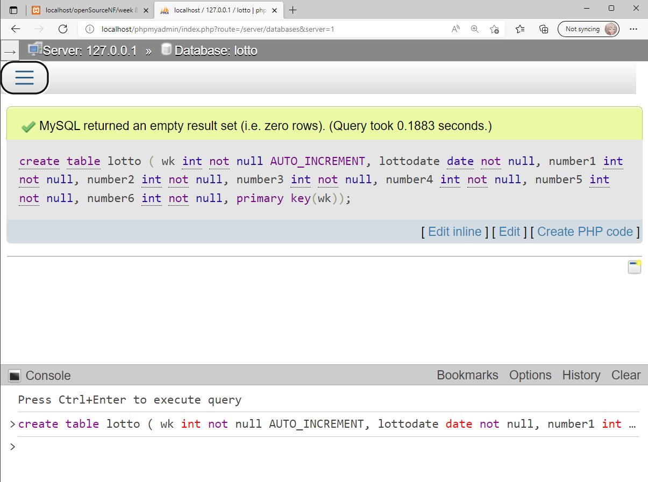

Exercise 3
The original script wk9ex1.php will now be modified to allow us to save the numbers to the lotto table. Add the new statements, substituting your username, password and databasename in the appropriate places.

<?php
$lottodate = date("Ymd");
echo "The lottery numbers for $lottodate are ";
for($n=1;$n<7;$n++){
$number[$n] = rand(1,49);
echo "<br/> $number[$n]";
}
$conn = mysqli_connect("localhost", username, password, databasename);

$sql = "insert into lotto (lottodate,number1,number2,";
$sql = $sql . "number3,number4,number5,number6)";
$sql = $sql . " values ($lottodate,$number[1],$number[2],";
$sql = $sql . "$number[3],$number[4],$number[5],$number[6]);";

$result = mysqli_query($sql);
echo "<br/>This weeks numbers have been saved";

?>

Run the script and check the values are being saved by logging into phpMyAdmin and viewing the data on the table (via the “Browse” tab).

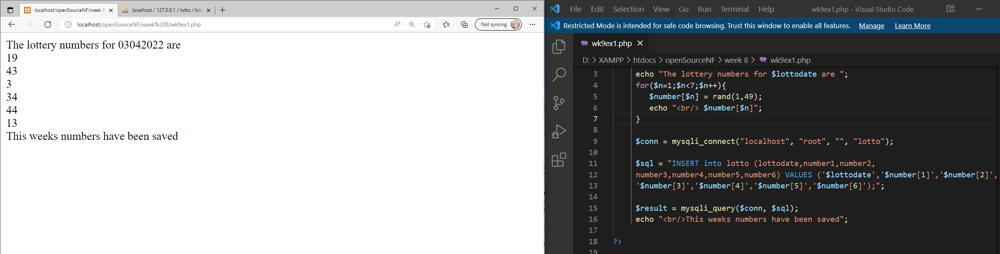
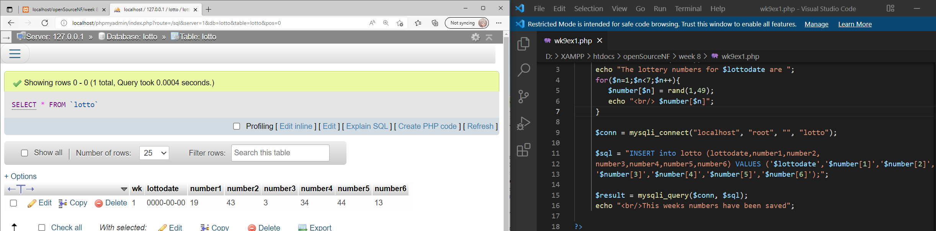

Exercise 4.
It would be useful to be able to look at previous lottery numbers. To achieve this we will write a new script that displays the lottery dates in a selection control. On selecting the date the script will display that dates numbers. Create the script below and save it as wk9ex4.php

<?php
$conn = mysqli_connect("localhost", username, password, databasename);
$sql = "select * from lotto;";
$result = mysqli_query($sql);

echo "<form action='$_SESSION[PHP_SELF]' method='post' >";
echo "<br/>Select the lottery week ";
echo "<select name='selweek' >";
while($row = mysqli_fetch_array($result)) {
echo "<option value='$row[wk]'>$row[wk]</option>";
}
echo "</select><br/>";
echo "<input type='submit' value='Select' />";
echo "</form>";
?>

Run the script to ensure it does display the lottery weeks within a selection box.

Finally we will add the code to display the numbers for the selected week. Modify wk9ex4.php in line with the script below.
<?php
$conn = mysqli_connect("localhost", username, password, databasename);

if ($_POST[selweek]){
$sql = "select * from lotto where wk=$_POST[selweek];";
$result = mysqli_query($sql);
$row = mysqli_fetch_array($result);

echo "Number 1 is $row[number1]<br/>";
echo "Number 2 is $row[number2]<br/>";
echo "Number 3 is $row[number3]<br/>";
echo "Number 4 is $row[number4]<br/>";
echo "Number 5 is $row[number5]<br/>";
echo "Number 6 is $row[number6]<br/>";
}
else {
$sql = "select * from lotto;";
$result = mysqli_query($sql);

echo "<form action='$_SESSION[PHP_SELF]' method='post' >";
echo "<br/>Select the lottery week ";
echo "<select name='selweek' >";
while($row = mysqli_fetch_array($result)) {
echo "<option value='$row[wk]'>$row[wk]</option>";
}
echo "</select><br/>";
echo "<input type='submit' value='Select' />";
echo "</form>";
}
?>

Run the script and check that the numbers displayed within the page correspond to the numbers in the table.

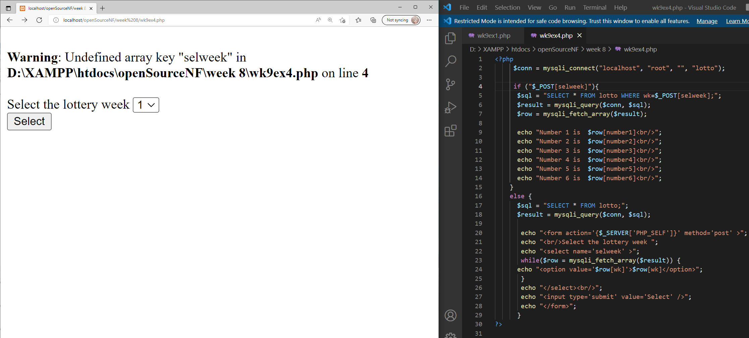
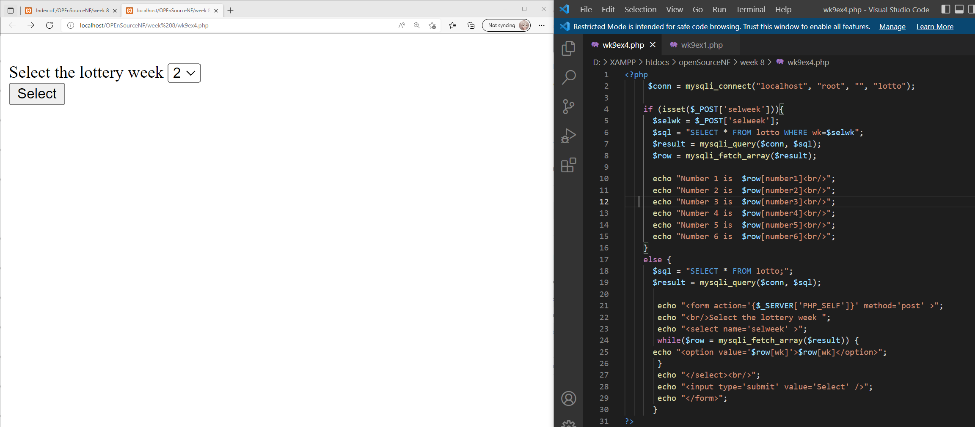
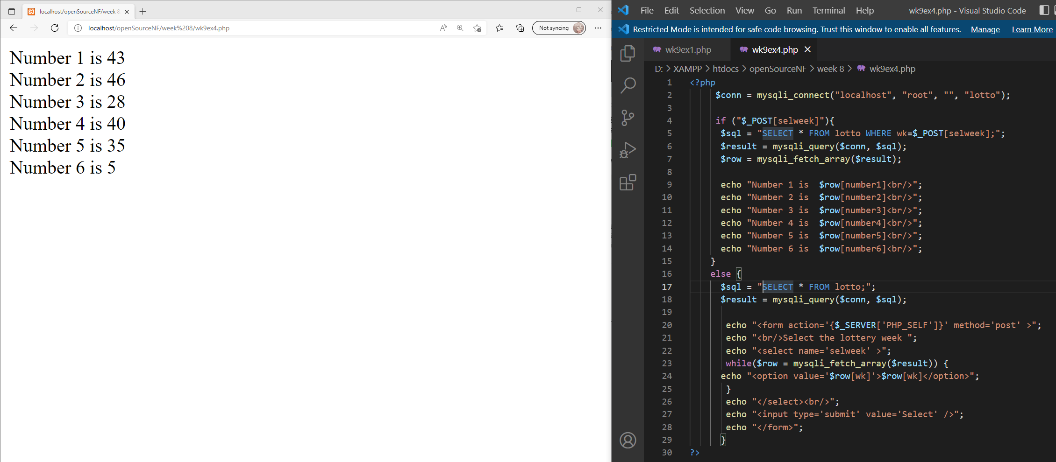

Exercise 5
Draw the UML design for the script wk9ex4.php.

Exercise 6

Complete the SoloLearn PHP course either via the web or via the mobile: https://www.sololearn.com/Play/PHP

Provide evidence that you completed the whole course in the form of a screenshot of your progress or a screenshot of the certificate of completion.

Make sure the screenshot identifies you as the person who has completed the course.

